**HTML PROJECT ON THE DEVELOPMENT OF**

**UNIVERSITY OF NIIT**

**WEBSITE**

Developed by

Name: **SABA, AYODELE SHAMSUDEEN**

Start Date : November 19, 2018

End Date : February 12, 2019

Name of the Coordinator : Mr Chisom

Name of Developer : Saba, Ayodele

Date of submission : February 14, 2018

**CERTIFICATE**

This is to certify that this report on the development of the University of NIIT website embodies the original work done by **Saba Ayodele** in partial fulfillment of their course requirement at NIIT.

Coordinator:

*Mr. Chisom*

**ACKNOWLEDGEMENT**

First I want to say Alhamdulillah and thank Almighty Allah for seeing me through the completion of this project. Then I would like to appreciate my uncle for assisting me financially in registration at NIIT. I would also like to appreciate my friends and colleagues in person of Taiwo, Warith, Farouq, Ace Kid, Silm and everyone else who helped me through this project with ideas and suggestions. Also I want to appreciate my Lecturer Mr Chisom for the knowledge impacted in me which made it possible for me to do this project.

**INTRODUCTION**

The University of UNIIT was founded in 2003. It presently has five Campuses in Surulere, VI, Ikeja and Ikorodu. Our campuses are located at very easy to reach and notice locations with modern day infrastructure, facilities and the best setup to enable students get the best form of knowledge.

The University of NIIT admits between 5000-7000 new students every session and we are known to produce some of the best graduates in the country. The University of NIIT has a staff strength of 2250 personals made up as follows: 1,050 Administrative and Technical staff and 1200 Academic Staff.

University of NIIT currently offers six courses which are Java Technologies, Web Development, .Net, Big Data, Data Analytics and Digital Marketing. In addition to this we have a standard and well equipped art studio, computer lab and activity hub to help students develop personal talents and use their leisure time productively.

**ACTIVITIES LIST**

The following tasks have been performed to meet the specifications of the project scenario:

1. I created a home page as Home.html. This page contains the log in form which links to the Courses page, a section which houses a “Get started” button which links to the About page. This page also contains a section of what the University of NIIT (UNIIT) offers, it also contains a section which houses a “Apply now” button which links to the Apply Now page. The page also has some more content.
2. I created an About Us page as about.html. This page tells you about UNIIT. This page also shows the members of the Management board.
3. I created a “Courses” page which shows all the courses offered in UNIIT.
4. I created an “Apply Now” page which houses a registration form for students who want to apply to UNIIT, the submit button in the form links to the Home page.
5. I created a Contact Us page which has all the contact details about UNIIT and also houses a Get In Touch form where people can send messages to the management of UNIIT.

1. I created some external style sheets to help in styling and beautifying all the Web page on the UNIIT site.
2. I also created an external java script and downloaded some scripts to help develop the website.

**HTML PAGES**

1. The following images displays the home page of the Web site, **home.html**



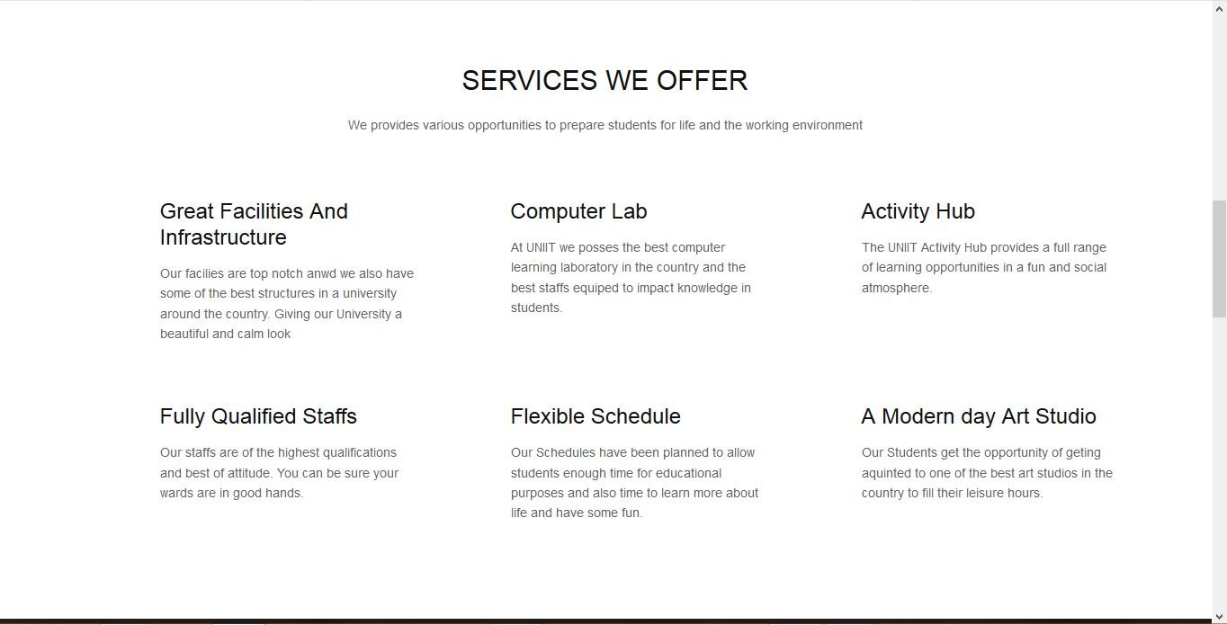



1. The following images displays the About page, **about.html.**

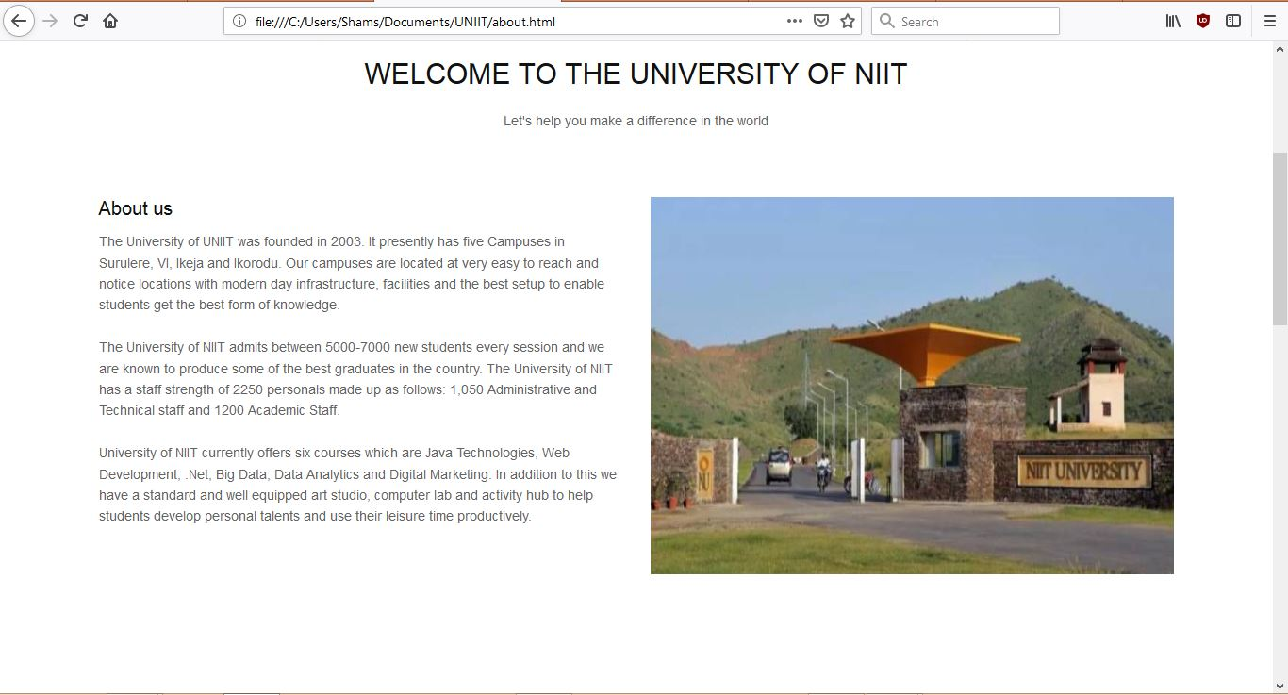

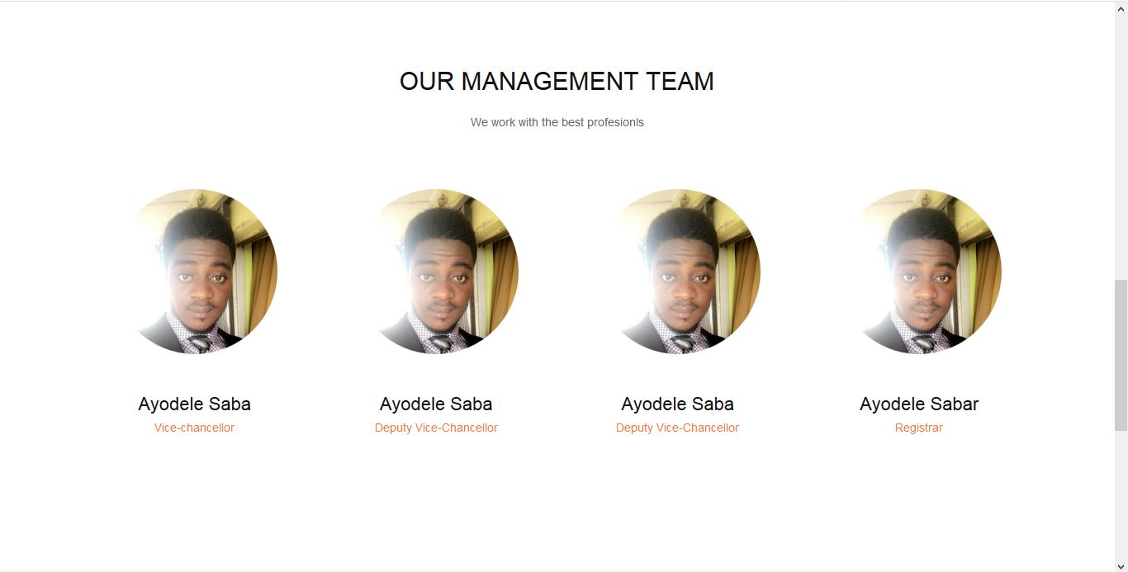

1. The image below displays the Courses page, **courses.html**

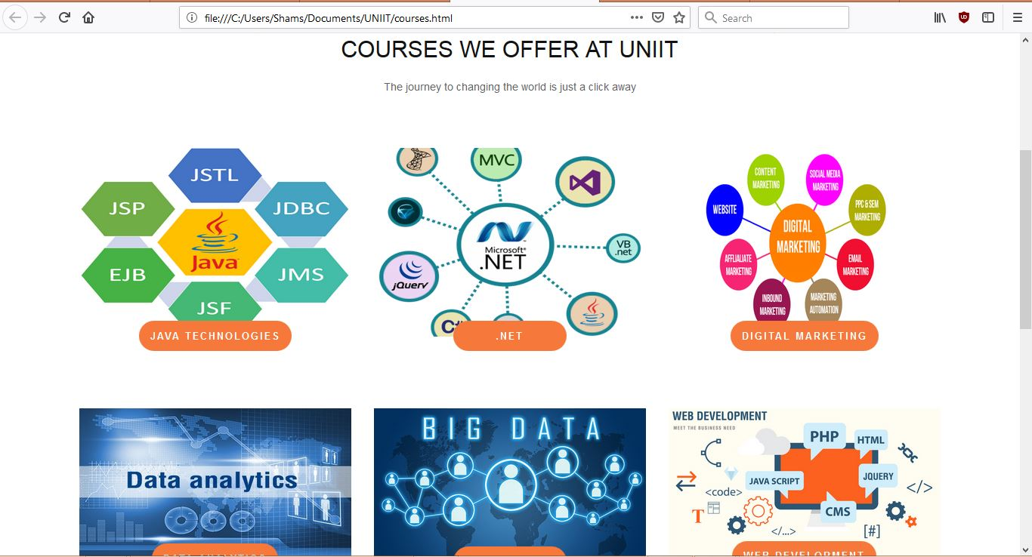

1. The image below displays the Apply Now page, **applynow.html**

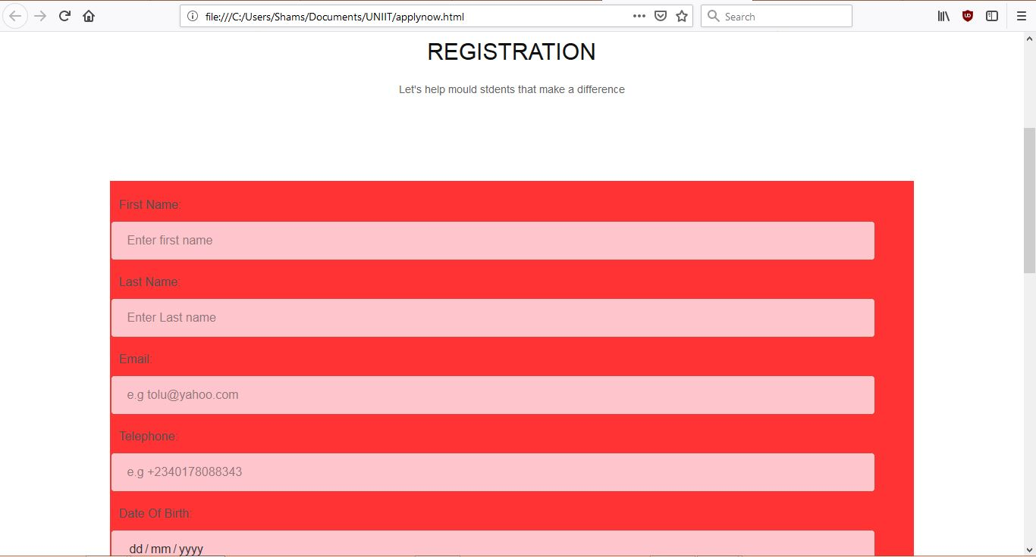

1. The image bellow displays the Contact us page, **contactus.html**

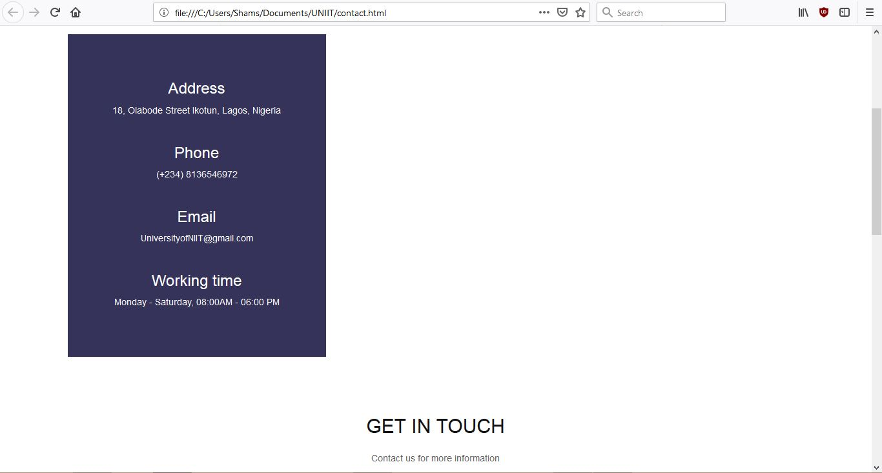

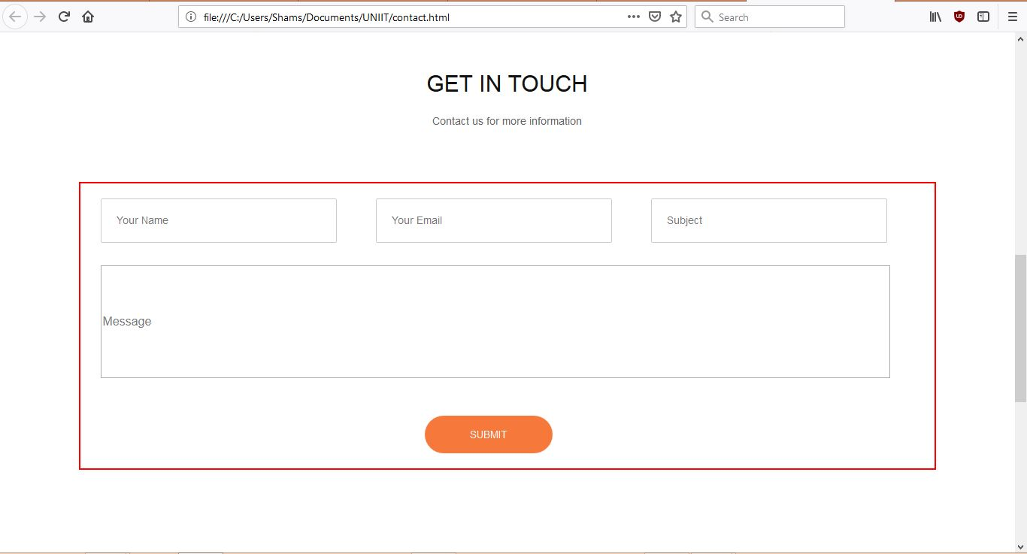

1. All web pages also contain a footer section shown in the image below

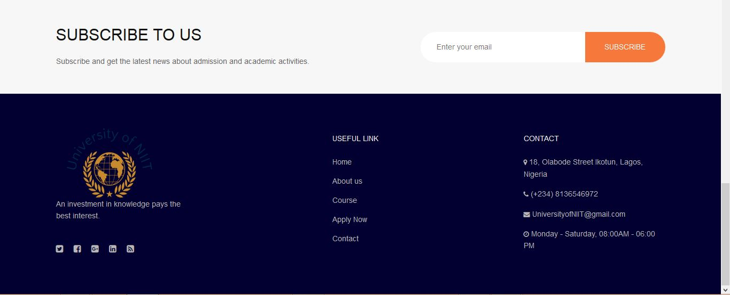

**JAVASCRIPT VALIDATIONS**

1. Java script validations were used in the forms on the home page, apply now page, contact us page and was also used in the subscribe to us section.

**SYSTEM CONFIGURATION**

**Processor: Intel(R) Pentium(R) CPU N3510 @ 1.99GHz 1.99GHz**, 4GB RAM and 500 GB Hard Disk

**Operating system:** Windows 10, 64-bit Operating system.

**Software:** Sublime text, Mozilla Firefox and Google Chrome.